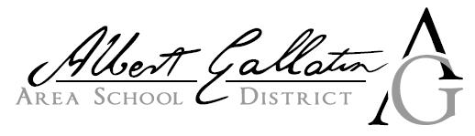
2625 Morgantown Road Uniontown, PA 15401 PHONE :(724)564-7190
_____________________________________________________

Change of Address
*Please print all information and return via email to Payroll at
jshwallon@agasd.org

To all employees:
To comply with the Earned Income Tax Regulations in this area, we must establish every employee’s correct taxing jurisdiction. As part of your employment records, it is important that you give both your mailing address and your resident taxing jurisdiction (City, Borough or Township, including County) below.

Name: ___________________________________________________

Street Address: ____________________________________________

City, State, and Zip: ________________________________________

Home Phone Number: ______________________________________

Cell Phone Number: ________________________________________

School District: ____________________________________________
^{(In which you live)}
Resident Taxing Jurisdiction*: ________________________________
(This is the City, Borough, or Township, including County, in which you live)

*Taxing Authority to which you file your annual local income taxes:
◻ Berkheimer
◻ SWRTB
◻ Central Tax

_________________ ____________________________
Date Employee Signature

